jClass Designer
Software Design Description

Author: Daniel Peterson
Debugging Enterprises
March, 2016
Version 1.0

Abstract: This document describes the software design for jClass Designer, a free Java application which enables the user to model and export UML Class Diagrams into skeleton code.

Based on IEEE Std 1016-2009 document format

Copyright © 2016 Debugging Enterprises, which is a made up company but is otherwise entirely real and serious, owns all rights to the jClass Designer and its subsidiaries. Any attempt to infringe upon the rights of Debugging Enterprises will result in swift legal action.

No part of this publication may be reproduced in any form, in an electronic retrieval system or otherwise,
without the prior written permission of the publisher.
1 Introduction

This is the Software Design Description (SDD) for the jClass Designer Java application.
Note that this document format is based on the IEEE Standard 1016-2009 recommendation for software design.

  - Purpose

This document is to serve as the blueprint for the construction of the jClass Designer application. This design will use UML class diagrams to provide complete detail regarding all packages, classes, instance variables, class variables, and method signatures needed to build the application. In addition, UML Sequence diagrams will be used to specify object interactions post-initialization of the application, meaning in response to user interactions or timed events.

  - Scope

jClass Designer will be a modeler for UML Class Diagrams. The user will be assumed to be familiar enough with software design that the usability of the application is enough to provide freedom to the user. Although this application will only support Java as the target language, future iterations may require that the number of support languages be extended. Therefore, a framework called LanguageFramework will be designed and constructed along with the jClass Designer application so that applications for other languages can be supported. This document contains design descriptions for the development of both the framework and the application.

  - Definitions, acronyms, abbreviations

Class Diagram – A UML document format that describes classes graphically. Specifically, it describes their instance variables, method headers, and relationships to other classes. Specifies the structural design of an object-oriented system.

Framework – In an object-oriented language, a collection of classes and interfaces that collectively provide a service for building applications or additional frameworks all with a common need.

GUI – Graphical User Interface, visual controls like buttons inside a window in a software application that collectively allow the user to operate the program.

IEEE – Institute of Electrical and Electronics Engineers, the “world’s largest professional association for the advancement of technology”.

Java – A high-level programming language that uses a virtual machine layer between the Java application and the hardware to provide program portability.

Sequence Diagram – A UML document format that specifies how object methods interact with one another. Specifies the dynamic design of a software system.

SRS – Software Requirements Specification. A document which specifies how an application (in this case, the jClass Designer) should function.

UML – Unified Modeling Language, a standard set of document formats for designing software graphically.

Use Case Diagram – A UML document format that specifies how a user will interact with a system. Note that these diagrams do not include technical details, rather, they are used as input to the design stage where the appropriate software designs are constructed based in part on the “Use Cases” specified in the SRS.

  - References

IEEE Std 830 – 1998 (R2009) – IEEE Standard for Information Technology – Systems Design – Software Design Descriptions.

jClass Designer SRS – Debugging Enterprises’ Software Requirements Specification for the jClass Designer application.

Wikipedia – Provides adequate definitions for UML Diagrams.

  - Overview

The software design description (SDD) will clearly describe how to construct the jClass Designer application using the specifications provided in the jClass Designer SRS. Note that all parties in the implementation stage must agree upon all connections between components before proceeding with the implementation stage. Section 2 of this document will provide the Package-Level Viewpoint, specifying the packages and frameworks to be designed. Section 3 will provide the Class-Level Viewpoint, using UML Class Diagrams to specify how the classes should be constructed. Section 4 will provide the Method-Level System Viewpoint, describing how methods will interact with one another. Section 5 provides deployment information like file structures and formats to use. Section 6 provides a Table of Contents, and Index, and References. Note that all UML Diagrams in this document were created using the VioletUML editor.

- Package-Level Design Viewpoint

As mentioned, this design will encompass both the jClass Designer application and the LanguageFramework to be used in its construction. In building both, we will rely heavily on the Java API to provide services. The following are descriptions of the components to be built, as well as how the Java API will be used to build them.

  - jClass Designer LanguageFramework overview

The jClass Designer and LanguageFramework will be designed and developed in tandem. Figure 2.1 specifies that all of the components which will be developed and places all classes in home packages.
Language Framework
jClass Designer
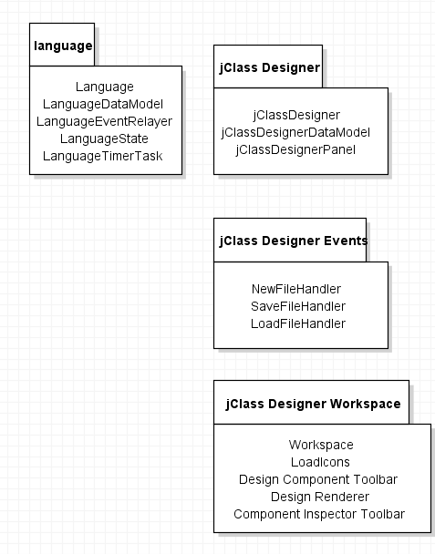
Figure 2.1: Design Packages Overview

  - Java API Usage

Both the framework and the jClass Designer application will be developed using Java. As such, this design will make use of the classes specified in Figure 2.2.

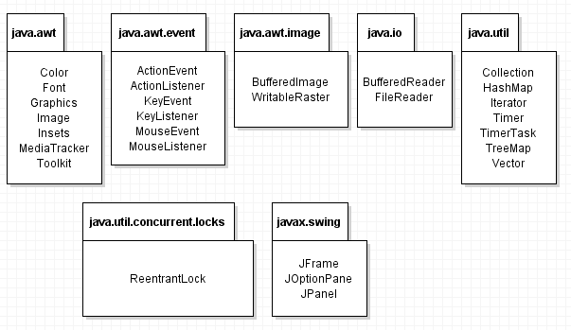
Figure 2.2: Java API Classes and Packages to be used

  - Java API Usage Descriptions

Tables 2.1-2.7 below summarize how each of these classes will be used.

Class/Interface | Use
Color | For setting the rendering colors for text and the progress bar
Font | For setting the fonts for rendered text
Graphics | For rendering text, images, and shapes to the canvas
Image | For storing image data
Insets | For changing component margins
MediaTracker | For ensuring synchronous image loading
Toolkit | For loading images

Table 2.1: Uses for classes in the Java API’s java.awt package

Class/Interface | Use
ActionEvent | For getting information about an action event like which button was pressed
ActionListener | For responding to an action event, like a button press. We will provide our own custom implementation of this interface
KeyEvent | For getting information about a key event, like which key was pressed
KeyListener | For responding to a key event, like a key press. We will provide our own custom implementation of this interface
MouseEvent | For getting information about a mouse event, like where the mouse was pressed
MouseListener | For responding to a mouse event, like a mouse press. We will provide our own custom implementation of this interface

Table 2.2: Uses for classes in the Java API’s java.awt.event package

Class/Interface | Use
BufferedImage | For storing image data where pixel information can be accessed and changed
WriteableRaster | For changing pixel data in a BufferedImage. We’ll use this to add transparency to pixels loading with the color key

Table 2.3: Uses for classes in the Java API’s java.awt.image package

Class/Interface | Use
BufferedReader | For reading text files, we’ll use this for loading some data at startup
FileReader | For reading files

Table 2.4: Uses for classes in the Java API’s java.io package

Class/Interface | Use
Collection | For storing groups of data, Values in a Map, i.e. TreeMap or HashMap are stored in Collections. We’ll need to iterate through Collections for rendering.
HashMap | For storing (name,value) key pairs, we’ll use it for storing our Images, accessible using their ID names
Iterator | For iterating through a data structure using operations like rendering
Timer | Will execute our custom task at fixed intervals
TimerTask | Our custom task to be executed at a fixed framerate. We will extend this class and provide the task implementation in the run method
TreeMap | For storing (name, value) key pairs, we’ll use it for storing GUI components, accessible using their ID names
Vector | For storing data like the Strings for rendering debugging text

Table 2.5: Uses for classes in the Java API’s java.io package

Class/Interface | Use
ReentrantLock | For ensuring only one thread has access to program data

Table 2.6: Use for classes in the Java API’s java.util.concurrent package

Class/Interface | Use
JFrame | Provides the window for our GUI
JOptionPane | Provides a popup dialog for error feedback
JPanel | Provides a canvas for the game to be rendered onto

Table 2.7: Uses for classes in the Java API’s javax.swing package

- Class-Level Design Viewpoint

As mentioned, this design will include both the jClass Designer application and the Language Framework. The following UML Class Diagrams reflect this. Note that due to the complexity of the project, the class designs are presented using a series of diagrams going from overview diagrams down to detailed ones.

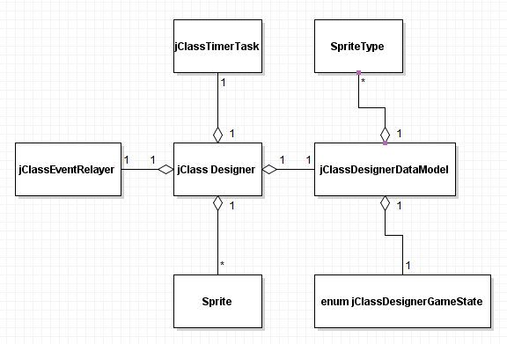

Figure 3.1: Language Framework Overview UML Class Diagram

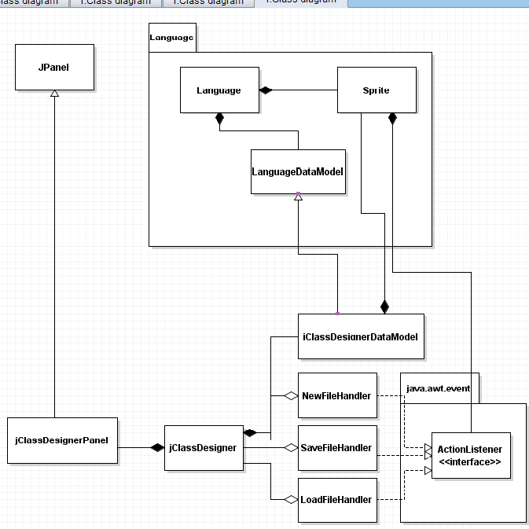

Figure 3.2: jClassDesigner Overview UML Class Diagram

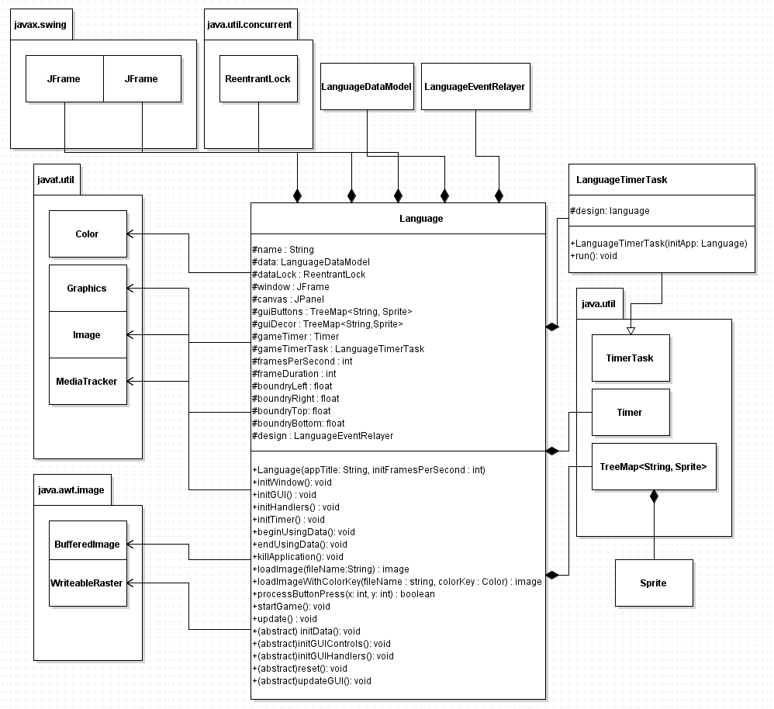
Figure 3.3: Detailed Language and LanguageTimerTask UML Class Diagram

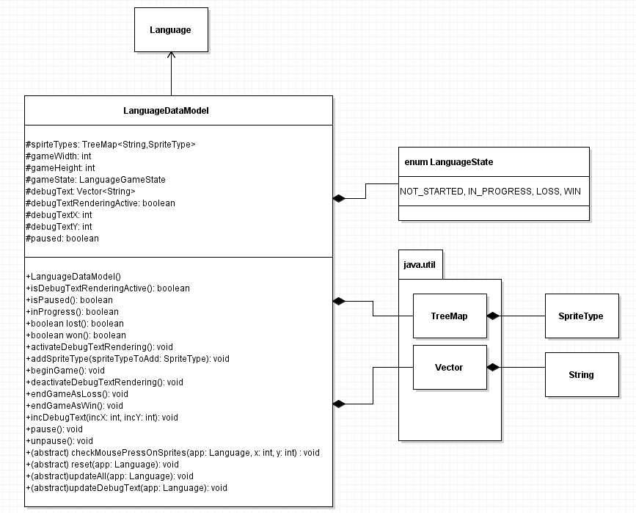
Figure 3.4: Detailed LanguageDataModel UML Class Diagram

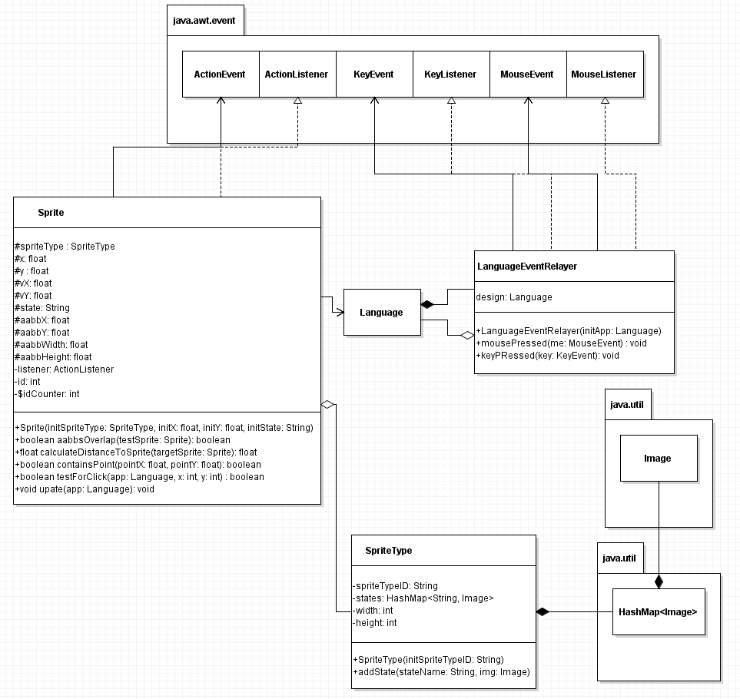
Figure 3.5: Detailed Sprite, SpriteType, and LanguageEventRelayer UML Class Diagram

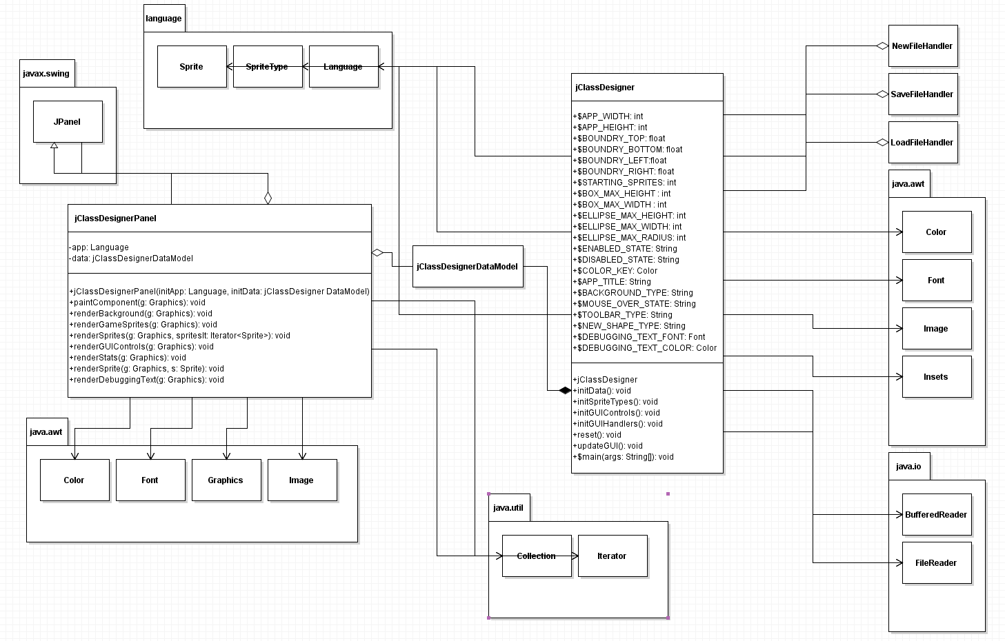
Figure 3.6: Detailed jClassDesigner and jClassDesignerPanel UML Class Diagram

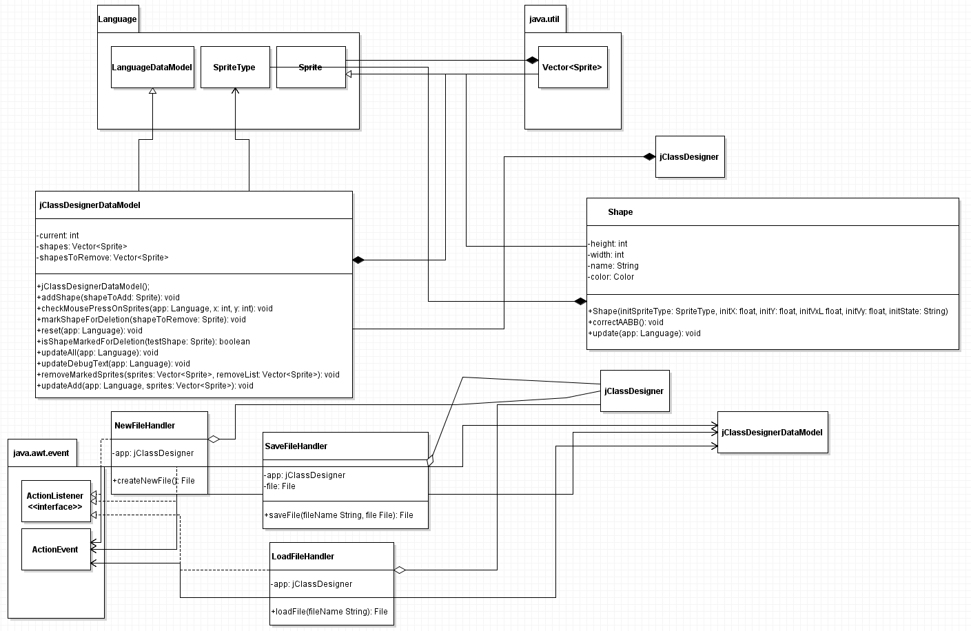

Figure 3.7: Detailed NewFileHandler, SaveFileHandler, and LoadFileHandler UML Class Diagrams
- Method-Level Design Viewpoint

Now that the general architecture of the classes has been determined, it is time to specify how data will flow through the system. The following UML Sequence Diagrams describe the methods called within the code to be developed in order to provide the appropriate event responses.

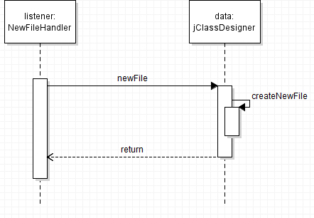

Figure 4.1: NewFileHandler UML Sequence Diagrams

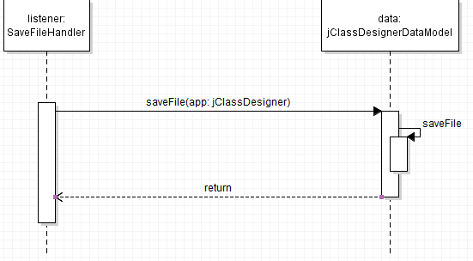

Figure 4.2: SaveFileHandler UML Sequence Diagrams

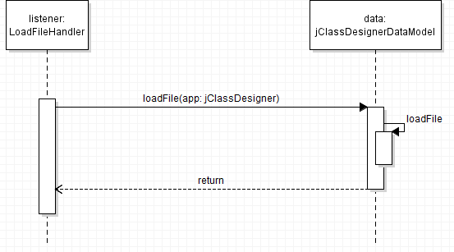

Figure 4.3: LoadFileHandler UML Sequence Diagram

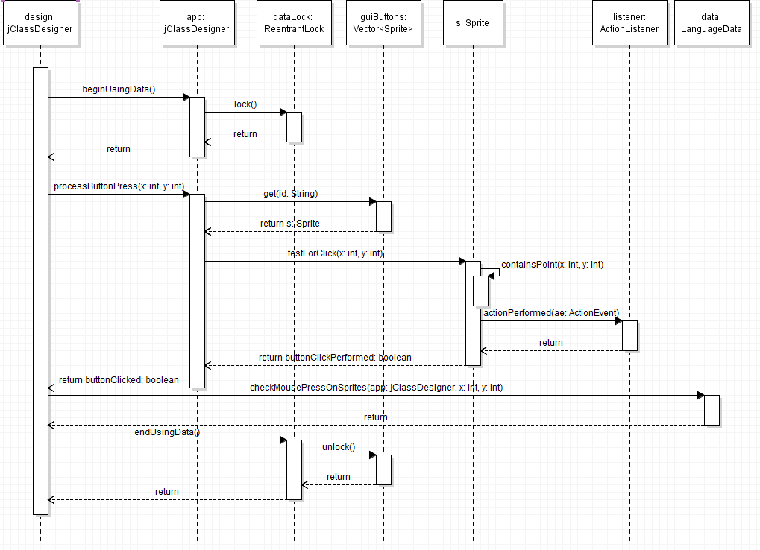

Figure 4.4: Mouse Click on Canvas UML Sequence Diagram

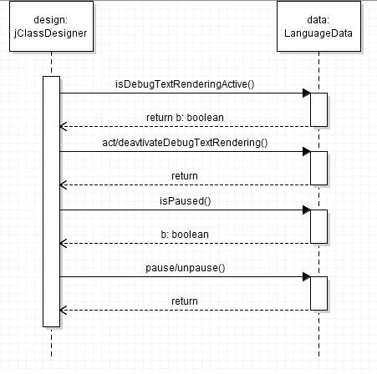
Figure 4.5: Key Press UML Sequence Diagrams

5. File Structure and Formats

Note that the Language Framework will be provided inside LanguageFramework.jar, a Java Archive file that will encapsulate the entire framework. This should be imported into the necessary project for the jClass Designer application and will be included in the deployment of a single, executable JAR file titled jClassDesigner.jar. Note that all necessary data and art files must accompany this program. Figure 5.1 specifies the necessary file structure the launched application should use. Note that all necessary images should of course go in the image directory.

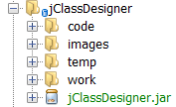

Figure 5.1: jClassDesigner File Structure

There must be a directory for the image file (containing all of the shapes and connecting lines placed by the user) which is rendered. These image files will be placed in the TEMP directory. A second directory, which will be called CODE, will contain the JAVA files with the skeleton code from the UML diagrams. There will also be an IMAGES directory to hold the art used for buttons and other icons in the toolbars. Finally, there will be a WORK directory which will hold the JSON files which contain all the data from the workspace.

6. Supporting Information

Note that this document should serve as a reference for those implementing the code, so we’ll provide a table of contents to help quickly find important sections.

6.1 Table of Contents

- Introduction
- Purpose 2
- Scope 2
- Definitions, acronyms, and abbreviations 2
- References 3
- Overview 3
- Package-Level Design Viewpoint 4
- jClass Designer and Language overview 4
- Java API Usage 5
- Java API Usage Descriptions 5
3. Class-Level Design Viewpoint 8
4. Method-Level Design Viewpoint 14
5. File Structure and Formats 17
6. Supporting Information 18
1. Table of contents 18
2. Appendices 18

6.2 Appendices

N/A

